MedBook

Software Development Plan

Version 1.0

Revision History

| **Date** | **Version** | **Description** | **Author** |
| --- | --- | --- | --- |
| 29/10/21 | 1.0 | Complete section 1, 2, 3, 4.1, 4.2, 4.3.1, 4.3.3 | NPVy, NNDu, NKTTNga |
|  |  |  |  |
|  |  |  |  |
|  |  |  |  |

Table of Contents

**1.** **Introduction 4**

**2.** **Project Overview 4**

*2.1* *Project Purpose, Scope, and Objectives 4*

*2.2* *Assumptions and Constraints 4*

*2.3* *Project Deliverables 4*

**3.** **Project Organization 4**

*3.1* *Organizational Structure 4*

*3.2* *Roles and Responsibilities 4*

**4.** **Management Process 4**

*4.1* *Project Estimates 4*

*4.2* *Project Plan 4*

4.2.1 Phase and Iteration Plan 5

4.2.2 Releases 5

4.2.3 Project Schedule 5

4.2.4 Project Resourcing 5

*4.3* *Project Monitoring and Control 5*

4.3.1 Reporting 5

4.3.2 Risk Management 5

4.3.3 Configuration Management 6

Software Development Plan

# 

# Introduction

This Software Development Plan will define the development activities for developing the MedBook App. Every detail of the development, test and deployment process will be covered in this document.

# Project Overview

## Project Purpose, Scope, and Objectives

Purpose: The primary goal of this project is to create an application that helps people to make an appointment with their doctors along with some convenient features.

Scope: This project is meant to reach out to everyone and every class of society.

Objectives: Create a fully functional application for making appointments and checking health for patients and doctors.

## Assumptions and Constraints

* The project has a fixed schedule of 10 weeks.
* Zero-budget project.
* The project has 5 people, there will be no more people added during the project.
* Android test only.

## Project Deliverables

Deliverables of the project are identified in the project schedule. Deliverables include:

* Vision Document
* Software Development Plan
* Software Architecture Document
* Test cases and reports
* Weekly Report
* Source code

# Project Organization

## Organizational Structure

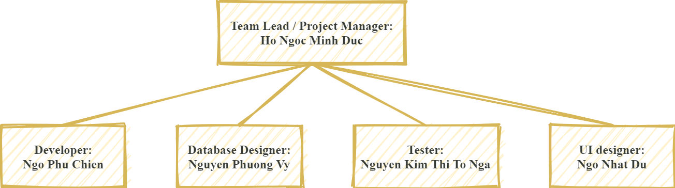

## Roles and Responsibilities

| ***Person*** | ***Role*** |
| --- | --- |
| **Hồ Ngọc Minh Đức**  **Ngô Phú Chiến**  **Nguyễn Phương Vy**  **Ngô Nhật Du**  **Nguyễn Kim Thị Tố Nga** | *Project manager*  *Developer*  *Database designer*  *UI designer*  *Tester* |

# Management Process

## Project Estimates

Project Time: 10 weeks ( 5 sprints)

Members: 5 people

## Project Plan

### Phase and Iteration Plan

| **Phase** | **Iterative** | **Objectives** | **Milestones** |
| --- | --- | --- | --- |
| Inception | Sprint 1 | Define the scope of project, business use-case, product requirements. Draw up the project plan and make a description of the project goal, risks, and business model. | Scope and business case agreement |
| Elaboration | Sprint 2 | Analysis, design use-case models, and specify the structure of each model. | Use-case model |
| Sprint 3 | Complete use-case specification and establish product prototype architecture. | Baselined architectural prototype. |
| Construction | Sprint 4 | Revise Software Architecture.  Design UI for the software system, implement and test M1 version. | M1 version |
| Sprint 5 | Fixing the previous version and complete implementation.  Test plan and test case. | M2 version |

### Releases

**M1 (MedBook version 1)** contains most of basic functions as below:

* Admin’s features
* Sign in and Sign up
* Set up/Manage appointment schedule
* Review appointment history and medical information
* Searching hospital’s and doctor’s information
* Notification

**M2 (MedBook version 2)** should have these features including:

* Discount
* Pay for treatment
* Human Resources Management

Some additional features may be implemented like:

* Update medical news
* Private Chat
* Donation

***Time releases:***

* M1: 11/12/2021
* M2: 25/12/2021

### Project Schedule

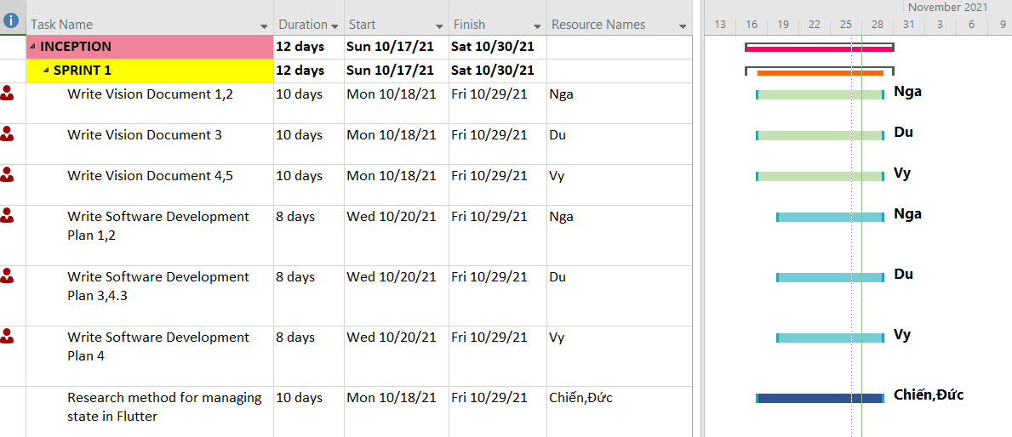

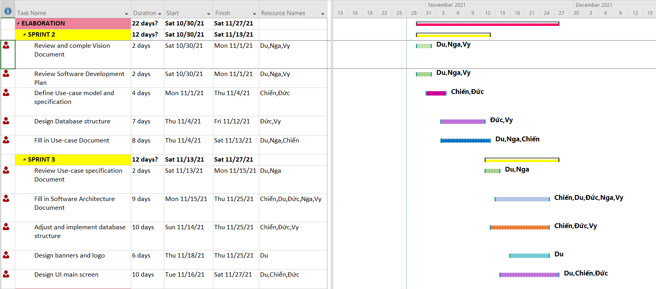

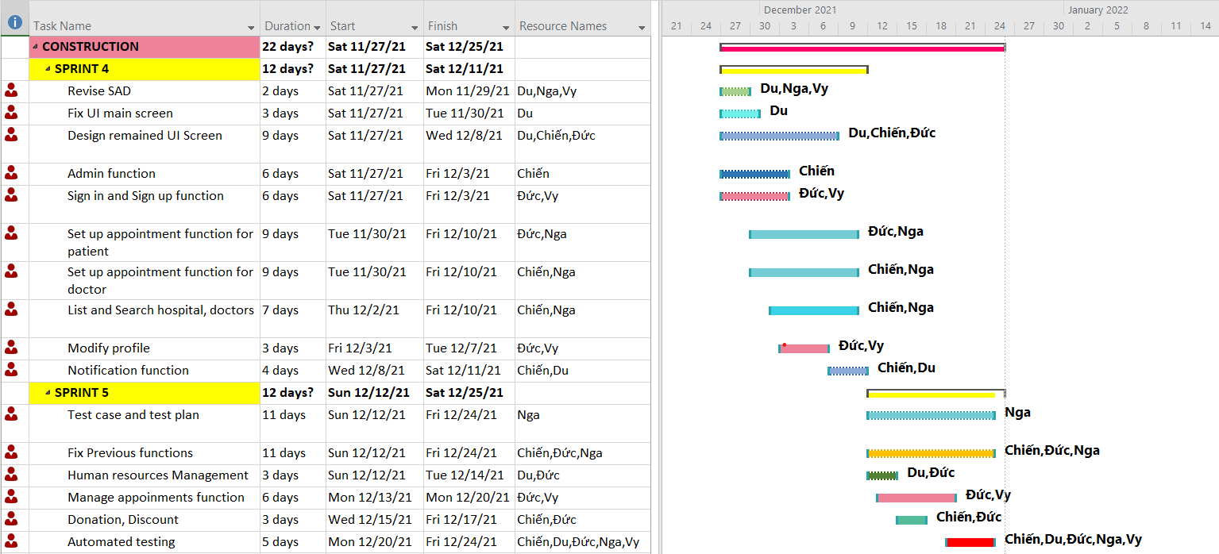

## Project Monitoring and Control

### Reporting

Weekly meeting via Zoom every Tuesday and every other Friday.

Weekly status report on Google Drive: update at every meeting.

Informal chats via Facebook Messenger group chat.

### Risk Management

*[Identify risks in your project. The risks should be prioritized, and shorted according to their priority.]*

| *Risk ID* | *Risk Description* | *Probability* | *Impact* | *Priority* | *Mitigation Strategy or Contingency Plan* |
| --- | --- | --- | --- | --- | --- |
|  |  |  |  |  |  |
|  |  |  |  |  |  |
|  |  |  |  |  |  |

### Configuration Management

Google Drive for storing and shuttering documents and files.

GitHub for managing code and related files.